GOVERNMENT OF TRIPURA
DIRECTORATE OF FAMILY WELFARE & P.M.
GURKHABASTI, AGARTALA

NO. F.12 (15-16)DFWPM/IEC/2014. Dated, Agartala the 27 /7/2016.

NOTICE INVITING TENDER

Tenders in sealed covers are hereby invited for the year 2016-2017 by the Director of Family Welfare & P.M., Government of Tripura, Agartala on behalf of the Governor of Tripura from the resourceful, experienced, bonafide, licensed manufactures or their authorized supplier/firm/person for Providing and installation of LED Scrolling Message Display Board/ Digital Multicolour Display Board

Name of works & Specification | Description | Estimated cost  (Rs. In lacs) | Time of Completion
LED Scrolling Message Display Board/ Digital Multicolour Display Board. (Specifications at annexure -A) | Providing and installation of LED Scrolling Message Display Board/ Digital Multicolour Display Board (size 5ft.x11inches) in moving manner with power supply etc. arrangement conforming to moving LED diodes (multicolour), power supply unit, Register unit, Control unit, display unit, assembled circuit, Assembled body, electrification fabrication etc. complete including the cost transportation etc. conforming 3(three) years maintenance assured based complete and installation in prominent front places of hospital as per direction of the Engineer-in-charge.  For- Different PHCs & CHCs as follows:-  1) Dhalai- PHCs/CHCs--18nos.  2) North- PHCs/CHCs 18 nos.  3) Unakoti- PHCs/CHCs 13 nos.  4) South- PHCs/CHCs 26 nos.  5) Gomati- PHCs/CHCs 16 nos.  6) West- PHCs/CHCs 15 nos.  7) Khowai- PHCs/CHCs 11 nos.  8) Sepahijala- PHCs/CHCs 19 nos.  Total - 136 nos. | Cost of materials – 0.22 Cost of transportation- 0.02  3 yrs maintenance 0.03  charge  Total 0.27 X 136 = 36.72  Including all taxes | 90(Ninety)  days

- Time allowed for completion of works is including Rainy Season.

- Bid document detailed terms & conditions will be available online on website healthtripura.gov.in from
27/7/2016 up to 31/8/ 2016.

- The tender will be dropped in the tender box only in sealed covers addressed to “The Director of Family Welfare & P.M., Government of Tripura, P.N. Complex, Gurkhabasti, P.O. Kunjaban, Agartala-799006” up to 4:00 p.m. of 29/8/2016 & tender will be opened at 03:00 p.m. on 31/8/2016, if possible. The undersigned will not be responsible for any postal delay. The tender shall remain valid up to 31/12/2017.

Sd. /illegible
27/7/2016

Director of Family Welfare & P.M
Government of Tripura, Agartala

TERMS & CONDITIONS
- On the top left side of the sealed tender enquiry number and date, due date of receive and address of Tenderer should be mentioned.
- The interested bidders shall submit the bids in 2(two) parts, namely “Technical Bid and Financial Bid”. The 2-bids should be put in two separate sealed envelopes, indicating on the cover as to which one is the technical bid and which one is the financial bid. The 2 envelopes shall, thereafter, be placed inside a large sealed cover and the same may be submitted. The “Technical Bid “ shall contain all details regarding the item offered by the bidder, compliance of terms and conditions, submission of documents etc. in other words, everything except the rate offered. The “Financial Bid” shall contain only the rate offered by the bidder. While processing the bids, the technical bids will be opened first and the eligible bidders meeting requirement will be short-listed. Thereafter, financial bids of only short listed bidders will be opened for consideration.
- 5% of the value of Estimated cost will have to be deposited as Security Money by demand draft from anyNationalized Bank by the firm within 20(twenty) days time from the date of issue of work order.

- Income Tax / other Tax shall be deducted from the bill as per guidelines of the Government, if applicable.
- Guarantee/Warranty:- The whole unit including consumables required to run this unit should be for guaranteed for 3(three) years.

- Tenderer should submit terms of year-wise Annual Maintenance Contract (AMC) for 05(five) years beyond warranty period. There should be 02(two) preventive maintenance work is to be done for LED Scrolling Message Display Board/ Digital Multicolour Display Board twice in a year at the interval of 06(six) months as a routine maintenance within the warranty period and breakdown call beyond maintenance work is to be attended within 72 hours of receiving the call.

- In case of out of order/breakdown call beyond maintenance work will be attended within 72 hours after receiving the call. A penalty at the rate of 1% for a week or a part of week of delay of attending call will be charged over the maintenance charge of the said items of unattended call.

- The Government will not consider any enhancement of rate within the validity period of contract except imposition of any levy or increase in exiting levy. Such request will lead to cancellation of order.

- Payment to successful Tenderer shall be made on bill basis only after successful installation and execution of work ordered for. No advance payment shall be made under any circumstances.

- The rate should be typed and quoted both in figure and words clearly in Indian currency. The rate of both CST & VAT should be mentioned separately and clearly in financial bid, in Indian currency only.

- Approximate requirement is incorporated in the table above which is likely to be increased or decreased as per actual requirement and work order may be placed in parts or fully as per discretion of the Director, FW&PM.

- The following self-certified / self-attested documents should be submitted along-with the Tender. (All the papers submitted with the tender are to be self-certified / self-attested).

- Up to date Tax Clearance Certificate
- PAN Card.
- Copies of valid trade license or renewal certificate thereof.
- Documents showing experience (Work order/experience certificate).
- Constitution of the firm of the tenderer.

13. The bidder shall provide Bank Deposit At- Call having validity to cover the period of tender from any Nationalized Bank for an amount of Rs 1,00,000/-(One Lac) only as Earnest Money along with the tender. This amount shall be released after validity period of tender, in case of successful bidders and that of un-successful bidders will be released after finalization of tender.
(Continued to P/2)

(Page-2)

14. Price quoted should be met F.O.R. Door delivery in any place of Tripura.

15. No insurance charge is admissible and successful Tenderer will be responsible for any damage and loss in transit on way to destination.

16. Any default or breach of contract and non-execution of work order shall lead to forfeiture of earnest money/security deposit of the successful Tenderer beside to such action as may be considered appropriate by the Director of Family Welfare & P.M., Government of Tripura, Agartala including black listing / delisting the Tenderer for the future purpose.

17. The Director of Family Welfare & P.M., Government of Tripura, Agartala reserves the right to accept or reject any tender without assigning any reason thereof and Tender may be accepted or rejected in part or in whole.

18. In case of legal dispute the jurisdiction will be the Tripura High Court, Agartala.

19. The massage 10 (Ten) nos. in the Annexure-‘B’ will be displayed in the LED Scrolling Message. Some alteration if required in future also may be done time to time.

Sd. /illegible
27/7/2016
Director of Family Welfare & P.M
Government of Tripura, Agartala.

Enclosed:-
- Annexure-A (specification of the item).
- Annexure-B (The massages which will be displayed in the LED Scrolling Message Board, Some alteration if required in future also may be done time to time.)
- Annexure-C (declaration by the Bidder to be submitted in Technical Bid).
- Annexure-C (list of documents should be submitted in technical Bid).

Sd. /illegible
27/7/2016
Director of Family Welfare & P.M
Government of Tripura, Agartala.

Annexure-A
LED Scrolling Message Display Board/Digital Multicolour Display Board
Technical Specification
- Used LED’s Fundamental Specification
- LED size & shape/Pixel size : 4-5 mm Oval/Round shape, white
- LED Type : P 10mm & ANA Compliance.
- Pixel pitch: : Matrix Led pitch less than 10mm to maintain good resolution.
- Pixel Density : 10000(dots/m2)
- Display size : 60” x 6”
- Cabinet Dimension : 10” x 67” x 4”
- Driving method : ¼ or 1/8 Scanning
- Level Vision : > 120’C
- Opening Temperature & Humidity : O-55’C & 0%-95% NON-CONSIDERING
- Working Voltage : AC 220V/ 110V + 10%
- Transmission Distance/Visibility range : 100 feet from the point of fixation and the elevation of 7-8 ft, from ground level, with absolute visual clarity.
- Life Span : 100000 Hrs.
- Brightness & Regulation : 3500-4500 Nits
- Used Memory/Character No. : Message will be stored in on board (Control Card) RAM.
- Font Size : Max 6”
- Mounting of LED : The LEDS would be mounted on FRP-4 grade Glass
Epoxy copper cladded Laminate based Printed
Circuit Boards, the ICs & Resistor would be mounted
on FRP-2 grade paper Caldded Laminated based PCB.
- Cabinet Specification:
- The Cabinet would be fabricated out of Aluminum Angles/ ACP Sheet and 3mm Transparent Acrylic Sheet, in the front for Digital portion of Display Board.
- Cabinet should be Dust protected and Splashing of Water as standard of IP54.
- Operation-
Data Entry: From a PC- Pentium IV, AMD ATHLON, or equivalent having an serial/ USB port and preloaded with windows XP/2000/98, within 180-200 meters of the display board which will provided by us.
- Power Supply:
SMPS for the CPU card for the ”Shift resistor” portion of the display board, complete with surge and spike suppressors and watchdog circuitry which is additionally provided to ensure trouble free performance over an extended period of operation.
- Software: Customized operation Software package developed in Visual Basic and operating in Windows XP environment to be provided to control the LED Message Display thru wire communication
- Technical Condition:
- 03 (three) year replacement warranty of the module from the date of installation/supply
- Having previous Purchase Order/Supply Order/Authorization Certificate from the Manufacturer Company before issuing tender notice.
- Installation must.
- Sale tax Registration with similar line of activities.
- Valid Trade License with similar line of activities.

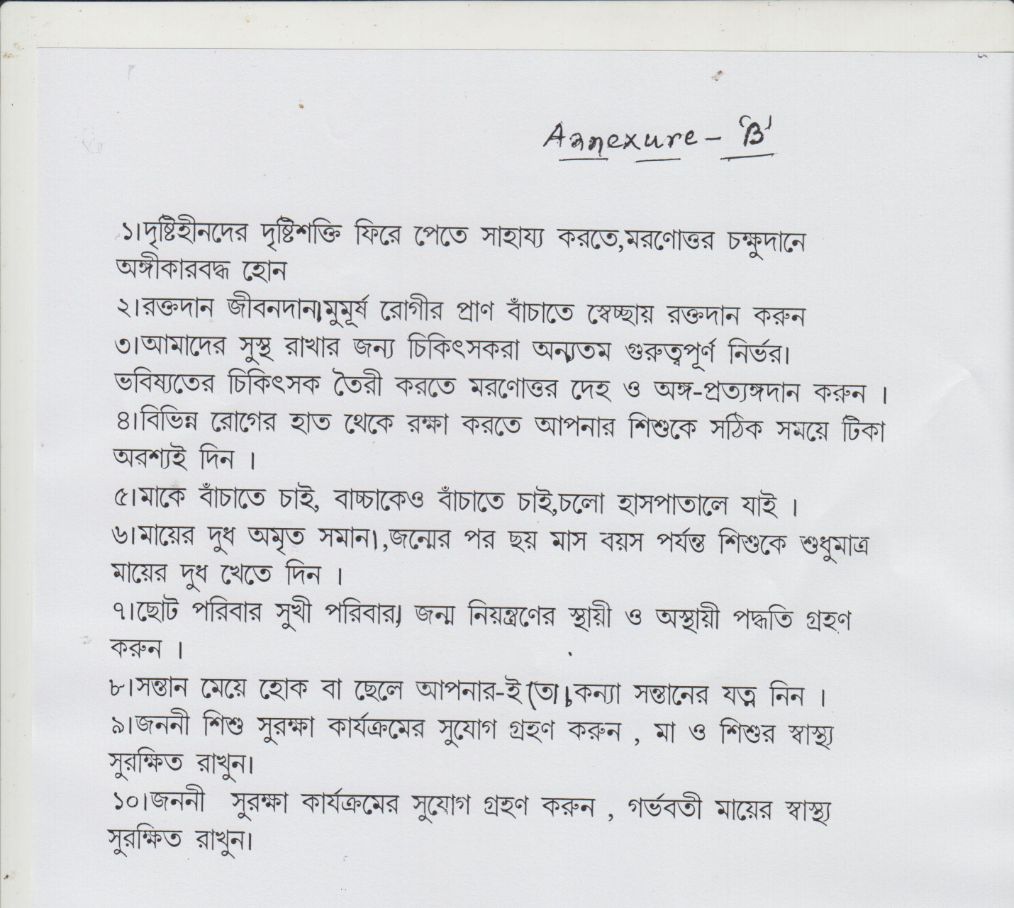

Annexure-C
Undertaking to be submitted by the tenderer

Tender No._____________________

For supply of ___________________

Sir,

I/We Sri / Smt. ………………………………………………, on behalf of M/s. ………………………………………………………… having registered office at……………….., do hereby declare that I/we have gone through the terms and conditions mentioned for the above and undertaken to comply with all tender terms and conditions. The rates quoted by me/us are valid and binding on me/us for acceptance for a period of 01(one) year from the date of award of contract to me/us.

2. I/We undersigned hereby bind myself/ourselves to the Office of ……………………………….……….to supply …….………………………………….. The rates quoted by me/us for the items tendered for are specified against each. It is certified that rates quoted are lowest quoted for any institution in India and not higher than the MRP/ prevailing market rate.
3. The articles shall be strictly as per specification and of the best quality as per requirement of the institution. The decision of the Office of …………………………………………………. (Hereinafter called the said Purchaser) as regards to the quality and specification of article shall be final and binding on me/us.
4. I/We agree to the conditions of the tender under which the EARNEST MONEY DEPOSIT and SECURITY DEPOSIT shall be forfeited by authority.
5. I/We hereby undertake to pay the penalty as per the terms and conditions of the contract for delayed supply of the ordered items.
6. I/We agree to accept the amount of the bill to be paid by the purchaser after completion of all formalities and should any amount of the bill found by the purchaser/auditors to have been over-paid; the amount so found shall be refunded by me/us.
7. I/We hereby undertake to supply the items during the validity of the tender as per direction given in supply order within the stipulated period.
8. The tender inviting authority has the right to accept or reject any or all the tenders without assigning any reason.
9. I/We understand all the terms and conditions of the contract and bind myself/ourselves to abide by them.

SIGNATURE.......................................................................................

NAME & DESIGNATION.......................................................................................

DATE......................................................................................................

NAME & ADDRESS OF THE FIRM....................................................................

Annexure-D

List of documents submitted should be given in a separate sheet within the Technical Bid.

Sl | List of documents | Page no
01 | Up to date Tax Clearance Certificate.
02 | PAN Card.
03 | Fresh deposit at call (D/Call) / Demand Draft drawn from any scheduled National Bank for an amount of Rs. 1,00,000.00 (Rupees One Lac) only.
04 | Copy of Valid Trade license or renewal certificate thereof.
05 | Constitution of the firm of the tenderer.
06 | Documents showing experience of such kind of work (work order/experience certificate).
07 | An undertaking for acceptance of terms & condition of the NIT as per annexure- B

* Attach separate sheets if the space is found insufficient in respect of these items.

SIGNATURE : ……………………………………………………………………

NAME & DESIGNATION : …………………………………………………………………..

DATE : …………………………………………………………………..

NAME & ADDRESS OF THE FIRM : …………………………………………………………………….

