Government of Tripura
Directorate of Family Welfare & P.M
Fax: 0381-232-6602. Email-dfwpmtripura@gmail.com

Tender No. F. VI (49)/-RFL/08 (Shadow File) Dated 03 /06/2016

NOTICE INVITING TENDER

Sealed Tenders are invited by the undersigned on behalf of the Governor of Tripura from the reputed and experienced manufacturer or their authorized Distributors for supply of Atomic Absorption Spectrophotometer for Regional Food Laboratory, Agartala for the year 2016-2017.

The tender form with detailed description of the items and terms and conditions may be available from the office of the undersigned on any working day during the office hours from 11:00 a.m. to 4:00 p.m., free of cost up to 20/6 /2016 and also available through the website www.healthtripura.gov.in The tender will be dropped in the tender box only in sealed covers addressed to “ The Director of Family Welfare & P.M., Government of Tripura, P.N. Complex, Gurkhabasti, P.O. Kunjaban, Agartala-799006” up to 4:00 p.m. of 21/6/2016 & tender will be opened at 3:00 p.m. on 23/6/2016 if possible. The undersigned will not be responsible for any postal delay. Rates of Instruments finalized through this process shall remain valid up to 31 July 2017. The Director of FW&PM, Government of Tripura may extend or curtail the validity period if deem fit. Tenderers are requested to provide detailed address along-with Pin Code, Phone and Fax numbers with S.T.D. Code number for communication.

Sd./

03/6/2016 Director of Family Welfare & P.M.,
Govt. of Tripura: Agartala.

TERMS & CONDITIONS
,
The tender will be dropped in the tender box only in sealed covers addressed to “The Director of Family Welfare & P.M., Government of Tripura, P.N. Complex, Gurkhabasti, P.O. Kunjaban, Agartala-799006” up to 4:00 p.m. of 21/6/2016 & tender will be opened at 3:00 p.m. on 23/6/2016 if possible. Tender received after the aforesaid date and hours shall be rejected. The Director of Family Welfare & P.M. shall not remain responsible for any postal delay. Tenderers are requested to provide detailed address along-with Pin Code, Phone and Fax numbers with S.T.D. Code number for communication.

,
1. At the time of submitting tender papers, the bidders/firms should mention full particulars of Director/Secretary/Authorized signatory and put their full signature on the tender papers. On the top left side of the sealed tender inquiry number and date, due date of receipt of tender and address of Tenderer should be mentioned. The detailed description of the items and terms and conditions may be obtained through the website www. healthtripura.gov.in

2. The interested bidders shall submit the bids in 2(two) parts, namely “Technical Bid and Financial Bid”. The 2-bids should be put in two separate sealed envelopes, indicating on the cover as to which one is the technical bid and which one is the financial bid. The 2 envelopes shall, thereafter, be placed inside a large sealed cover and the same may be submitted. The “Technical Bid” shall contain all details regarding the item offered by the bidder, compliance of terms and conditions, submission of documents etc. in other words, everything except the rate offered. The “Financial Bid” shall contain the rate offered by the bidder. While processing the bids, the technical bids will be opened first and the eligible bidders meeting requirement will be short-listed. Thereafter, “Financial bid” of only short listed bidders will be opened for consideration”.

,,,
,
3. The list of item with detailed specification at annexure-A.

4. The Instruments must be supplied directly by the firm itself or by it’s authorized distributors and should obtain sales tax clearance by the supplier before delivery. An authorized representative of the firm should remain present during delivery of the ordered quantity.

5. The supply order of instruments must be completed within 60 (sixty) days from the date of issue of order. A penalty @ 1% on the total value shall be charged for every week or part of week of delay beyond stipulated date of supply. However, Relaxation will be entertained only in special circumstances (Natural Calamities, War or any other situation beyond human control).

6. 5 % of the value of ordered quantity will have to be deposited in favour of the Director of Family Welfare & Preventive Medicine, Government of Tripura as security money by demand draft from any Nationalized Bank by the firm within 20(twenty) days time from the date of issue of supply order/before receiving item.

7. Income Tax / Sales Tax will be deducted from the bill as per guidelines of the Government, if applicable.

Continued Page no.-2

Page no-02

8. Any enhancement of rate within the validity period of contract will not be considered except for imposition of any levy or increase in existing levy by the Government & any undue request may lead to cancellation of the order.

9. Payment to successful Tenderer shall be made on bill basis only after completion of supply including successful installation / demonstration of the items as ordered for. No advance payment shall be made under any circumstances.

10. Guarantee/Warranty:-The whole unit including all other accessories, required to run this unit should be guaranteed for two years.

,
11. a) The rate should be typed and quoted both in figure and words clearly. The rate of both CST & VAT should be mentioned separately and clearly. Rate should be quoted in Indian currency only.

b) The rate of instruments should contains (i) basic price, (ii) any tax for calculating the price of the instrument/ equipment (iii) Annual Maintenance Contract for 5 year beyond warranty period, which will be added as part of the cost for comparison purpose.

c) Tenderer should submit terms of year-wise Annual Maintenance Contract (AMC) for 5(five) years beyond warranty period. There should be 2(two) preventive maintenance. The maintenance work is to be done for twice in a year at the interval of 6(six) months as a routine maintenance within the warranty period and breakdown call beyond maintenance work is to be attended within 72 hours of receiving the call.

d) In case of out of order/breakdown call beyond maintenance work will be attended within 72 hours after receiving the call. A penalty at the rate of 1% for a week or a part of week of delay of attending call will be charged over the maintenance charge of the said instruments of unattended call.

12. When tender is submitted by the authorized distributor/ supplier, the name of manufacturer should be mentioned against each item for which the rate is quoted. When a tender is submitted by authorized distributor / supplier of more than one manufacturer, rate should be quoted separately for each item showing the name of manufacturer against each item.

13. The following self-certified / self-attested documents should be submitted along-with the tender and all the papers are to be self-certified / self-attested.

i) Attested copy of PAN Card.
ii) Up to date Sales Tax Clearance Certificate (TCC).
iii) Valid quality assurance certificate like ISI/ISO/BIS etc.
iv) Up to date valid Trade License in respect of authorized distributor/supplier.
v) Up to date Income Tax Clearance Certificate (IT).
vi) Up to date Manufacturing License in case of manufacture.
vii) DGFT certificate, if the item is an imported one.
viii) Any pre condition laid down by the firm.
14. EMD @ 5% [five per cent] of quoted value on any Schedule Bank only is to be deposited in favour of Director of Family Welfare & Preventive Medicine, Government of Tripura along with the tender as Earnest Money which will be released after validity period of contract in case of successful tenderer and that of unsuccessful tenderer will be released after finalization of tender.
Continued Page no.-3
Page No-03

,
15. Mode of delivery: - Price should be quoted on F.O.R. Door delivery basis to the Regional Food Laboratory (RFL), Pt. Nehru Complex, Gurkhabasti, Agartala, Tripura(West).

16. No insurance charge is admissible and successful tenderer will be responsible for any breakage, damage and loss in transit on way to destination.

17. Any default or breach of contract and non-execution of supply order shall lead to forfeiture of earnest money/security deposit of successful tenderer beside to such action as may be considered appropriate by the Director of Family Welfare & P.M., Government of Tripura, Agartala including black listing / delisting the tenderer for future.

18. If any item supplied is found to be not of Standard quality, the same should be taken back and replaced by fresh stock at own cost of supplier.

19. The tenderer, who is not a manufacture or who quoted rate for the product of manufacturer shall furnish a letter of authority from the manufacture of the products authorizing the tenderer to quote the rate on their behalf. Such tenderer shall also furnish an undertaking that in the event of acceptance of the rate, he will supply the products of the manufacturer for which he quoted the rate.

20. The manufacturers having Marketing Agency at Agartala, Tripura will be preferred during consideration of rate & firm by a constituted committee.

21. a) Satisfactory certificate from the competent authority where the tenderer had already supplied the listed Instrument earlier may be submitted along with the tender in the part of technical bid.
b) Literature/booklet etc. in connection with each machine/equipment as available should be accompanied with the technical bid.

22. Director of Family Welfare & P.M., Government of Tripura, Agartala reserves the right to accept or reject any tender without assigning any reason thereof and tender may be accepted or rejected in part or in whole.

23. In case of any legal dispute the jurisdiction will be the Tripura High Court/ Consumer forum at Agartala.

24. The Director of Family Welfare & P.M., Government of Tripura, Agartala reserves the right to unilaterally terminate contract or cancel the acceptance of the rate or supply order at any time without notice before expiry of the period for which rate are now invited.

25. Extension of rate for supply may be considered for 2nd year to the approved supplier on the basis of satisfactory performance and execution of supply order in time and in terms of quality.

Sd./illegible
03/6/2016
Director of Family Welfare & P.M
Government of Tripura, Agartala

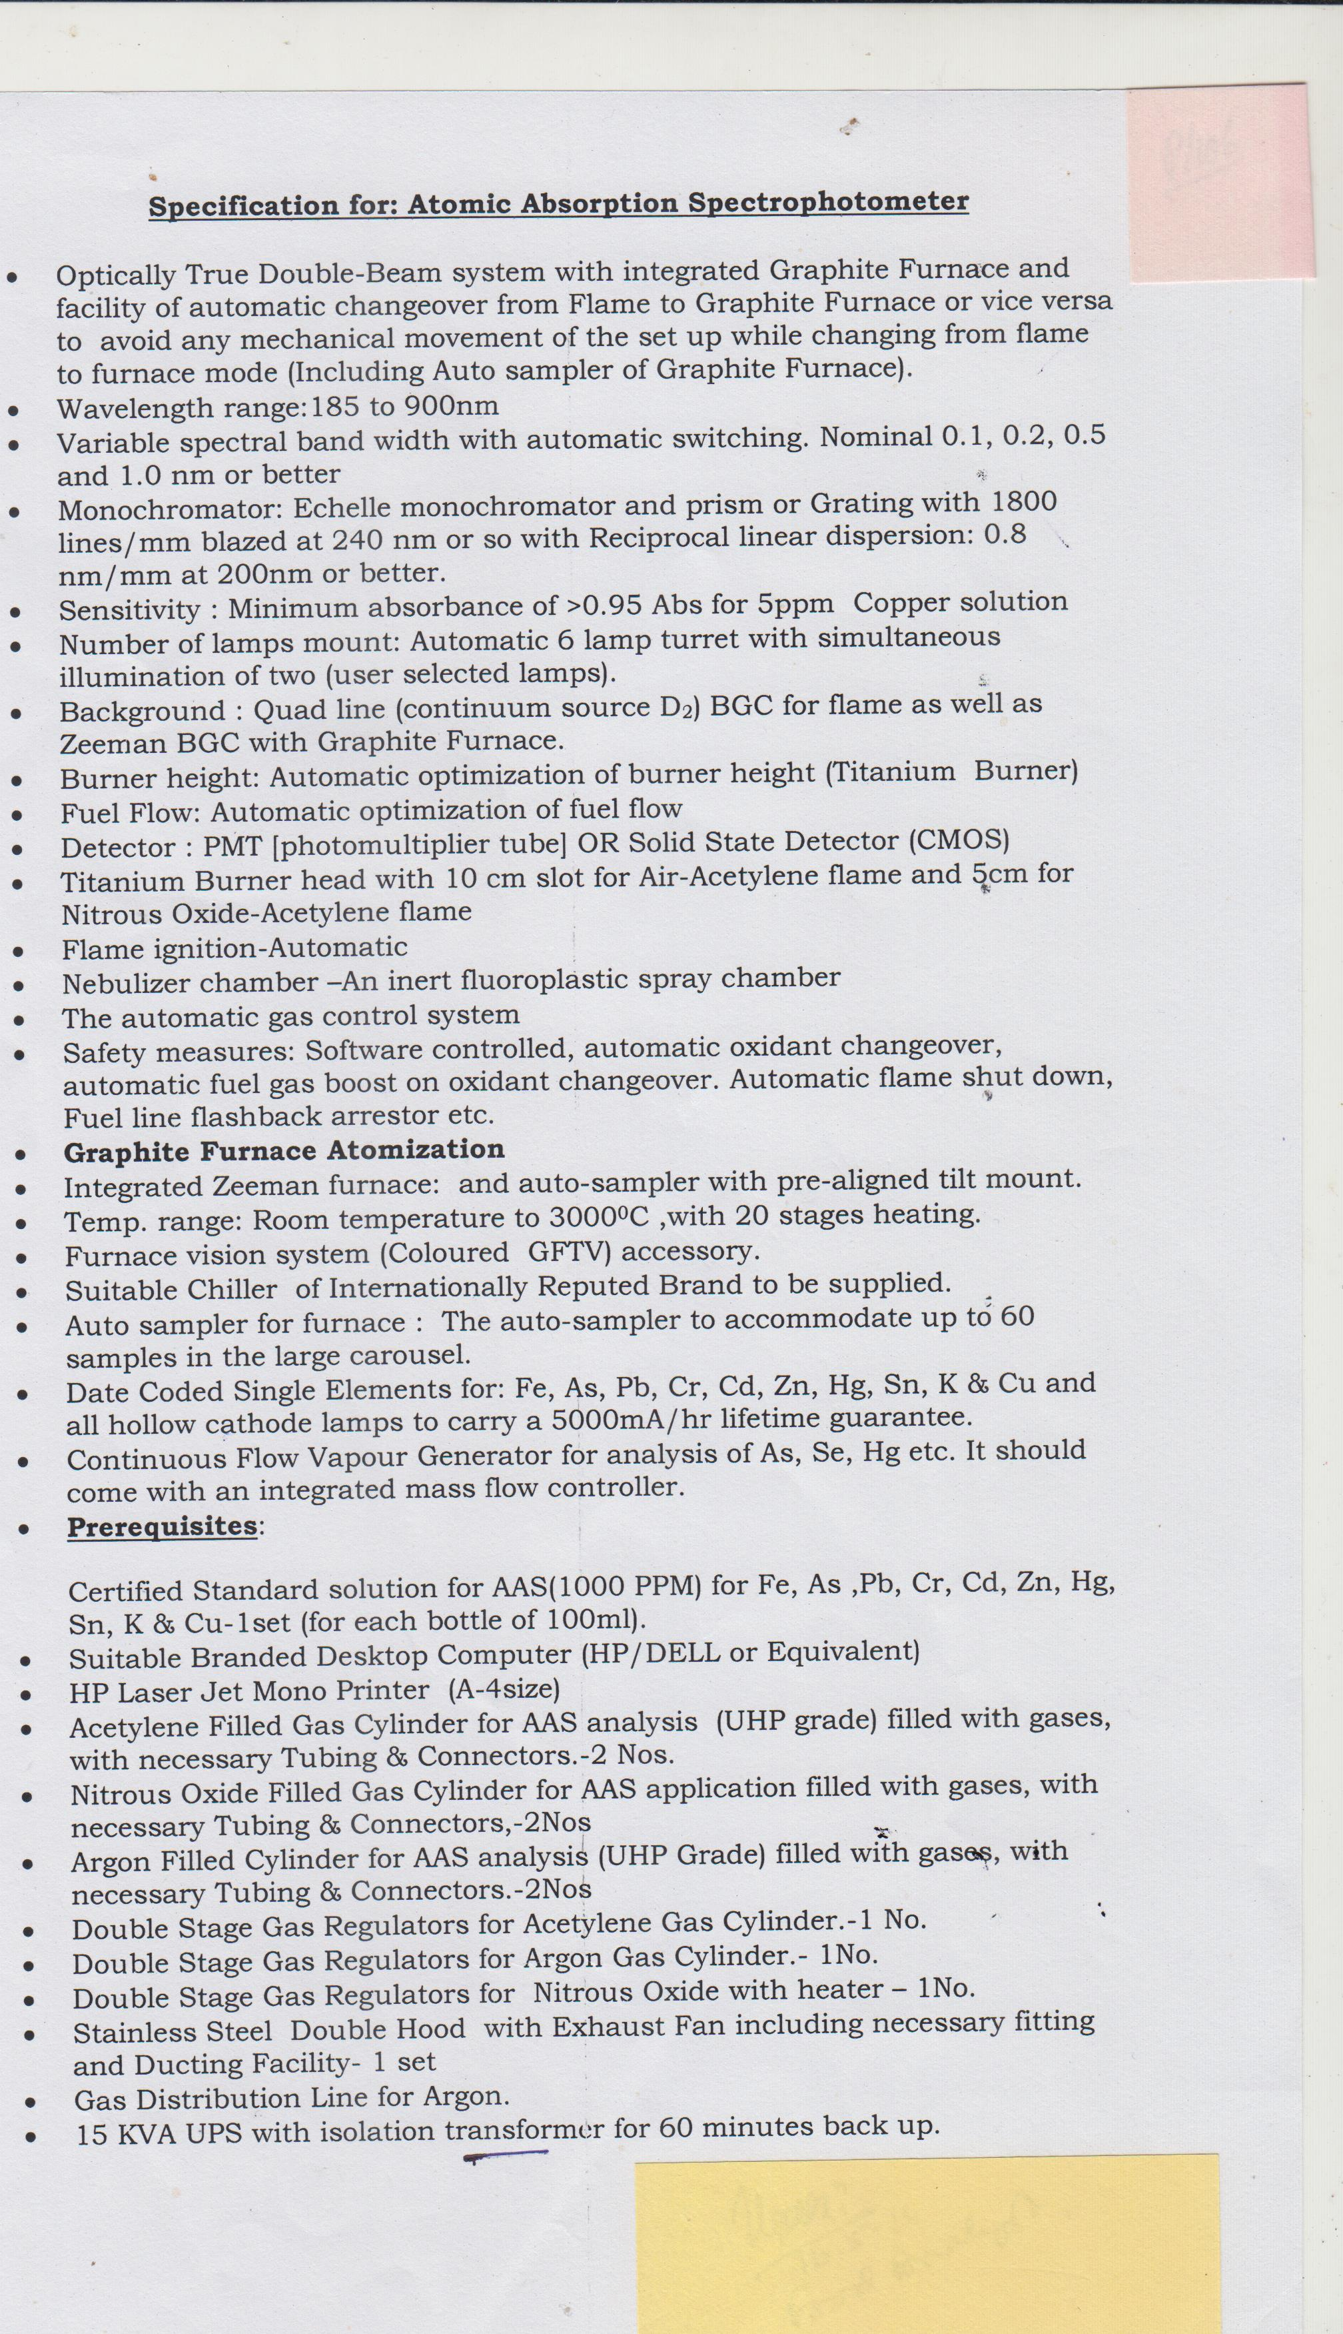

TECHNICAL SPECIFICATION QUOTED BY THE FIRM IN RESPECT OF PURCHASE OF Atomic Absorption Spectrophotometer FOR THE YEAR 2016-17 VIDE NO. F. VI (49)/-RFL/08 (Shadow File) Dated……….

-------------------------------------------------------------------------------------------------------------------

Name of the Supplier/Distributor / Manufacturer and Address:-
,,,

-------------------------------------------------------------------------------------------------------------
Submitted Tender paper in 2 bids, namely
‘Technical bid and financial bid’ separately :-

- Attested copy of PAN Card :-

- Up to date Sales Tax Clearance Certificate (TCC) :-

- Valid quality assurance certificate like ISI/ISO/BIS or any other approved standard :-
- Up to date valid Trade License in respect of authorized distributor/supplier:-

- Up to date Income Tax Clearance Certificate (IT). :-

- Upto date manufacturing license of respective manufacture:-

- Earnest Money Deposit EMD @ 5% [five per cent] of quoted value on any Schedule Bank only:-

- List of items detailed specification and name
of manufacturer, quoted by bidder :-

- Any pre condition laid down by the firm :-

Signature

Tender Enquiry No. F. VI (49)/-RFL/08(Shadow File)

Dated……. /06/2016

Sign of Bidder Page -------

Declaration by the Bidder:

1. This is to certify that I/We before signing this tender have read and fully understood all the terms and conditions contained in Tender document regarding terms & condition of the contract, rules regarding Purchase of Atomic Absorption Spectrophotometer & . I/we agree to abide them.

2. No other charges would be payable by Client and there would be no increase in rates during the Contract
period.

(Signature of Bidder with seal)
Place:…………………………………
Date:…………………………………
Name :

Seal :

Address:

